Default Email Signature & Font Instructions

- Open the Email Signature Standard document attached. Edit all fields to be yours/your property information. Highlight the signature for your property (DM or DQ) and press “CTRL C” together on your keyboard.

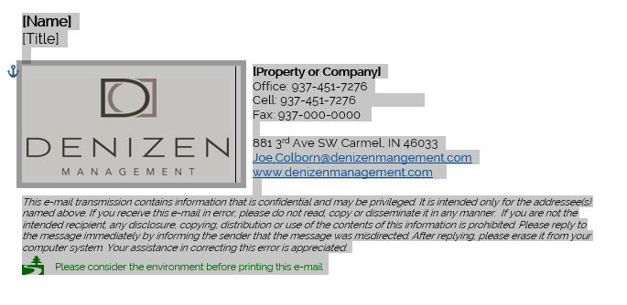

- Open your Outlook email app and select the File tab.

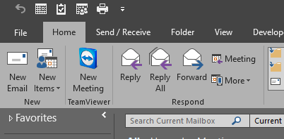

- Select Options on the far left.

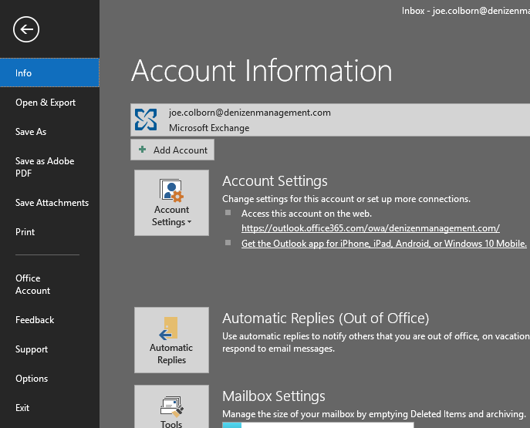

- Select “Mail” on the left and then “Signatures” on the right.

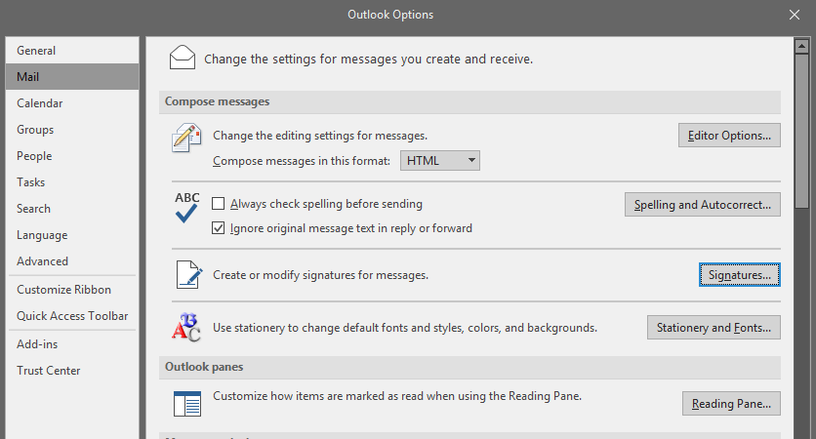

- Select “New”, type your name as the new signature, and press “OK”

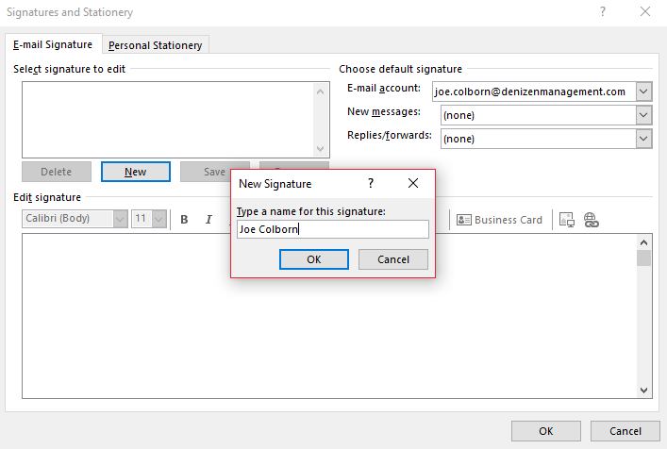

- In the blank space under “Edit Signature” right click and paste your signature using the “Keep Source Formatting” option (second icon with the clipboard and paintbrush) and hit “OK”.

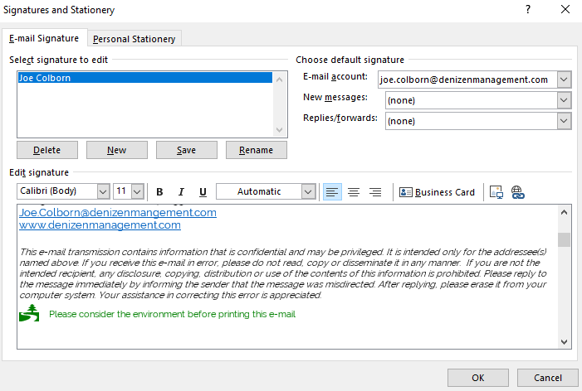

- Set your default signature on the far right to be your name on both new messages and replies.

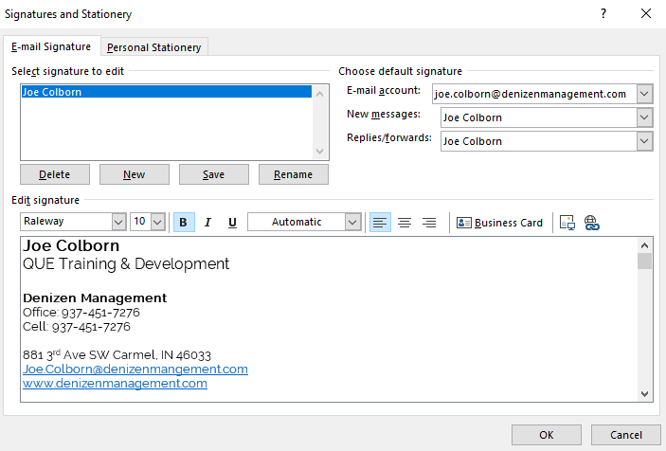

Just an FYI – when you copy and paste, the Denizen or Denizen QUE graphic it will not show up here, It will, however, show up on your signature in your email.

- Set your default Font to “Raleway” and “12” point size by selecting “Personal Stationary” and clicking on all 3 Font icons. All 3 will need to be set.

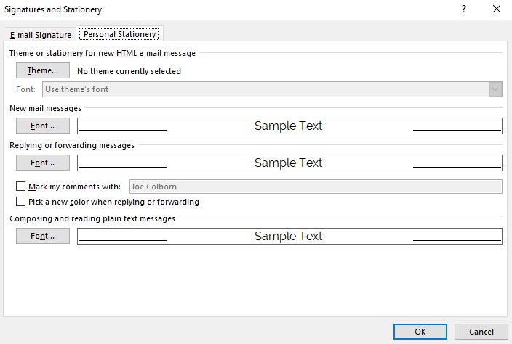

- Send a test email to ann.kesmodel@denizenmanagement.com with your new email signature to ensure it is correct.

